**SPAM CLASSIFICATION**

**A Capstone Project Report**

Submitted to

**SAVEETHA INSTITUTE OF MEDICAL AND TECHNICAL SCIENCE**

In partial fulfilment for the completion of course

**CSA1351-Theory of Computation with Recursive Language**

By

**M. Shivani Reddy [192210275]**

Supervisor

**DR. C. Anitha**



**SAVEETHA SCHOOL OF ENGINEERING**

**SAVEETHA INSTITUTE OF MEDICAL AND TECHNICAL SCIENCE**

**JUNE 2024**

**SAVEETHA SCHOOL OF ENGINEERING**

**Abstract:**

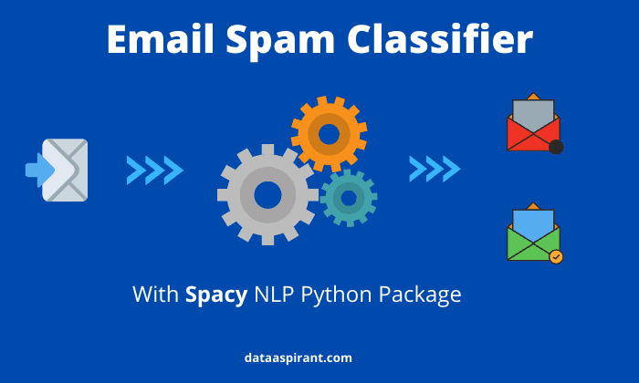Spam classification in Natural Language Processing (NLP) represents a critical challenge with practical implications across diverse domains. This project aims to equip students with practical expertise in tackling real-world problems through hands-on application of NLP techniques. By focusing on identifying and filtering out spam messages from legitimate ones, students will delve into essential NLP tasks such as text preprocessing, feature extraction, and model training.

The project fosters learning outcomes in data preprocessing techniques, feature engineering, and the application of machine learning algorithms like Naive Bayes, Support Vector Machines, and neural networks for classification tasks. Additionally, students will gain insights into model evaluation, hyperparameter tuning, and the ethical considerations of data handling in sensitive domains like personal communication. Through this project, participants will not only acquire technical proficiency in NLP but also develop critical thinking skills in problem-solving, data interpretation, and model optimization, preparing them for challenges in the evolving landscape of data-driven decision-making.

Error identification and correction are critical aspects of spam classification systems, aimed at reducing false positives and false negatives. This involves analysing misclassified messages, refining feature extraction methods, evaluating and selecting appropriate machine learning models, and implementing strategies like ensemble learning and real-time feedback mechanisms. These efforts aim to enhance the accuracy and reliability of spam detection, ensuring effective filtering of unsolicited and potentially harmful communications while optimizing user experience and digital security.

Top of Form

Bottom of Form

**Problem Statement:**

Spam emails, messages, and other forms of unsolicited communication pose significant challenges in both personal and organizational contexts. The objective of this project is to develop an efficient spam classification system using Natural Language Processing (NLP) techniques. The system will distinguish between legitimate messages and spam by analysing textual content, thereby helping users manage their communication more effectively.

Spam remains a pervasive issue in electronic communications, posing threats ranging from phishing scams to malware distribution and unwanted advertisements. The challenge lies in effectively distinguishing between legitimate messages crucial to users and unsolicited content that undermines productivity and security. Current spam filters often rely on rule-based systems or simplistic keyword matching, which can be circumvented by evolving spam tactics and variations in message content. Therefore, there is a pressing need for advanced spam classification systems leveraging Natural Language Processing (NLP) techniques.

These systems must intelligently analyse the content and structural attributes of emails or messages to accurately identify and filter out spam. Key objectives include developing robust feature extraction methods that capture subtle linguistic cues, integrating machine learning algorithms capable of learning from diverse data sources, and implementing ethical considerations such as privacy protection and bias mitigation. By addressing these challenges, the project aims to enhance email security, improve user experience, and mitigate the risks associated with malicious and unwanted communications in digital environments.

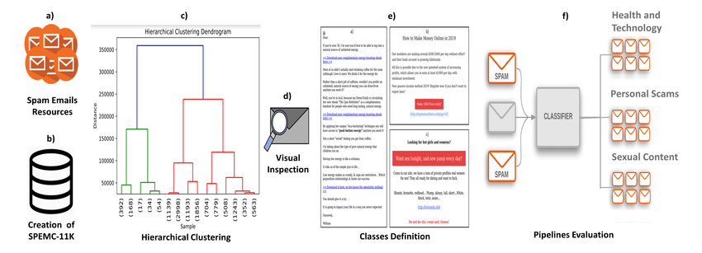

**Text Classification Techniques:**

**1. Bag-of-Words (Bow) and TF-IDF:**

* **Bow:** Represents each email or message as a vector of word frequencies.
* **TF-IDF:** Weighs the importance of words in each message relative to their frequency across the entire corpus.
* **Application:** Effective for traditional spam detection by capturing common spam keywords and patterns.

**2. N-grams:**

* **Description:** Sequences of n consecutive words extracted from text.
* **Process:** Capture local context and phrases that may indicate spammy content (e.g., "get rich quick", "free offer").
* **Application:** Enhances Bow by preserving some word order and contextual information important for spam classification.

**3. Word Embeddings:**

* **Description:** Dense vector representations of words capturing semantic meanings.
* **Application:** Use pre-trained embeddings or train specific embeddings on a large corpus to understand nuanced language and detect subtle spam patterns beyond simple keywords.

**4. Machine Learning Algorithms:**

* **Naive Bayes:** Simple and efficient for text classification tasks like spam filtering due to its assumption of independence between features.
* **Support Vector Machines (SVM):** Effective for binary classification tasks where it finds a hyperplane that best separates spam and legitimate messages.
* **Ensemble Methods:** Combine multiple classifiers (e.g., Voting Classifier, Bagging) to improve robustness and accuracy.

**5. Deep Learning Models:**

* **Convolutional Neural Networks (CNNs):** Process email content in a hierarchical manner, extracting patterns that indicate spam.
* **Recurrent Neural Networks (RNNs) and Long Short-Term Memory (LSTM):** Capture sequential dependencies in email text, useful for detecting sophisticated spam tactics.
* **Attention Mechanisms:** Focus on important words or phrases within emails that are indicative of spam content.

**6. Feature Engineering:**

* **Domain-Specific Features:** Include features like email header information, sender domain analysis, and structural features of emails (e.g., HTML content).
* **Behavioural Features:** Analyse user behaviour patterns (e.g., clicking on links, marking emails as spam) to supplement content-based features.

**7. Transfer Learning:**

* **Adaptation of Pre-trained Models:** Fine-tune language models (e.g., BERT, GPT) on spam classification tasks to leverage their understanding of semantic relationships and contextual cues.

**8. Evaluation Metrics:**

* **Precision, Recall, F1-score:** Measure the effectiveness of spam classification models in correctly identifying spam while minimizing false positives and false negatives.
* **Receiver Operating Characteristic (ROC) curve and Area Under the Curve (AUC):** Assess the classifier's ability to discriminate between spam and legitimate messages across different thresholds.

**9. Ethical Considerations:**

* **Privacy and Data Handling:** Ensure compliance with data protection regulations when collecting and processing email content.
* **Bias Mitigation:** Address biases in training data and models to ensure fair and unbiased spam detection.

**FEATURE EXTRACTION:**

In spam classification, feature extraction involves deriving meaningful attributes from email or message content that facilitate the identification of spam versus legitimate messages. These features are essential as they encapsulate distinctive elements that can be effectively utilized by machine learning models for accurate classification. Commonly extracted features include textual characteristics such as word frequencies, which highlight the prevalence of certain terms often associated with spam, such as "free," "discount," or "urgent." Additionally, features like TF-IDF (Term Frequency-Inverse Document Frequency) scores provide a measure of the significance of terms within individual messages relative to their occurrence across the entire dataset, aiding in the differentiation of spammy content from regular correspondence.

Structural features, such as email headers containing sender information and routing details, offer insights into the origins and authenticity of messages. Behavioural features, such as user interaction patterns (e.g., click-through rates, spam markings), and temporal attributes (e.g., time of email receipt) provide contextual clues that further enhance the classification process. Linguistic features like the use of special characters or stylistic anomalies can also be indicative of spam, contributing to a holistic approach in feature selection. By integrating and analysing these diverse features, spam classifiers can effectively discern and mitigate the impact of unsolicited communications, thereby enhancing email security and user experience.

**ERROR IDENTIFICATION AND CORRECTION:**

Error identification and correction in spam classification is a critical aspect aimed at improving the accuracy and reliability of spam detection systems. The primary challenge lies in minimizing false positives (legitimate messages incorrectly classified as spam) and false negatives (spam messages incorrectly classified as legitimate), which can impact user experience and operational efficiency.

To address these challenges, advanced techniques in error identification and correction are essential. This involves:

1. **Error Analysis:** Conducting thorough analysis of misclassified messages to understand patterns and underlying reasons for classification errors. This includes examining both false positives and false negatives to identify common characteristics or features that contribute to misclassification.
2. **Feature Engineering:** Enhancing feature extraction methods to capture more nuanced aspects of text data that distinguish between spam and legitimate messages. This may involve refining textual, structural, and behavioural features to improve the classifier's discriminatory power.
3. **Model Evaluation and Selection:** Rigorous evaluation of machine learning models using appropriate metrics such as accuracy, precision, recall, and F1-score. This helps in identifying the best-performing model and fine-tuning hyperparameters to optimize performance.
4. **Ensemble Methods:** Employing ensemble learning techniques such as bagging, boosting, or stacking to combine multiple classifiers and reduce classification errors. Ensemble methods leverage the diversity of individual models to improve overall predictive accuracy and robustness.
5. **Error Correction Strategies:** Implementing strategies to correct misclassifications in real-time or post-processing. This may involve incorporating user feedback mechanisms to refine classification decisions based on user interactions (e.g., marking messages as spam or not spam).
6. **Continuous Improvement:** Establishing mechanisms for continuous monitoring and retraining of the spam classification model. This ensures adaptation to evolving spam tactics and changes in user behaviour over time.
7. **Ethical Considerations:** Addressing ethical implications in error correction, such as ensuring transparency in how errors are identified and corrected, protecting user privacy during data handling, and mitigating biases that may affect classification outcomes.

**DATA PREPROCESSING:**

Data preprocessing in the context of spam classification involves several crucial steps to prepare raw textual data for effective use in machine learning models. These steps ensure that the data is clean, structured, and appropriately formatted, enhancing the accuracy and efficiency of the classification process. Here’s an outline of the key aspects of data preprocessing:

1. **Data Cleaning:**
   * **Remove HTML tags:** Strip HTML tags from email bodies to focus on textual content.
   * **Remove special characters:** Eliminate non-alphanumeric characters that do not contribute to the classification task.
   * **Normalize text:** Convert text to lowercase to ensure consistency in word representations.
2. **Tokenization:**
   * **Split text into tokens:** Break down text into individual words or tokens, which serve as basic units for analysis.
3. **Stop word Removal:**
   * **Filter out stops words:** Remove common words (e.g., "and", "the", "is") that do not carry significant meaning for classification purposes.
4. **Normalization:**
   * **Stemming or Lemmatization:** Reduce words to their root form to consolidate similar terms (e.g., "running" and "ran" to "run").
   * **Spell correction:** Address typos and spelling errors to improve text quality and consistency.
5. **Feature Extraction:**
   * **Vectorization:** Convert text data into numerical representations (e.g., Bag-of-Words, TF-IDF) that machine learning models can process.
   * **Embeddings:** Utilize word embeddings (e.g., Word2Vec, Glove) to capture semantic relationships and contextual meanings of words.
6. **Handling Imbalanced Data:**
   * **Up sampling or down sampling:** Adjust the balance between spam and non-spam (ham) messages to prevent bias towards the majority class.
7. **Data Splitting:**
   * **Training and test sets:** Divide the pre-processed data into training and testing subsets to evaluate model performance effectively.
8. **Dimensionality Reduction:**
   * **PCA or feature selection:** Reduce the number of features to enhance model efficiency and reduce computational complexity.
9. **Handling Missing Data:**
   * **Imputation:** Replace missing values with statistical measures (e.g., mean, median) to maintain data integrity.
10. **Data Encoding:**
    * **Label encoding:** Convert categorical data (e.g., spam/ham labels) into numerical values for model compatibility.

**CONCLUSION:**

Data preprocessing plays a pivotal role in preparing raw textual data for effective spam classification using machine learning techniques. By systematically cleaning, tokenizing, and normalizing text data, we ensure that the information fed into our models is consistent and meaningful. Features extracted through techniques like Bag-of-Words, TF-IDF, and word embeddings enable our models to capture semantic relationships and contextual meanings crucial for distinguishing between spam and legitimate messages. Handling imbalanced data, splitting datasets for training and testing, and reducing dimensionality further optimize model performance and computational efficiency. Ultimately, rigorous data preprocessing not only enhances the accuracy and reliability of spam classification systems but also contributes to improved digital security and user experience by effectively filtering out unwanted and potentially harmful communications. As spam tactics evolve, continuous refinement of these preprocessing methods remains essential to stay ahead of emerging threats and maintain robust protection in digital communication environments.